Screenshots or program listings must be copied into appropriate cells in the following table.
Save this evidence document as evidence_ followed by your centre number_ candidate number, for example, evidence_ zz999_9999 and insert your name, centre number and candidate number into the header above.
Examiners must be able to read the contents including any screenshots without the use of a magnifying glass. Answers that are not readable or are missing will not be awarded any marks.
Save this evidence document at regular intervals, for example every 10 minutes.
Question 1
Part 1(a)
global Animals
Animals = [""] * 10

Part 1(b)
def main():
global Animals
Animals = ['horse','lion','rabbit','mouse','bird','deer','whale','elephant','kangaroo','tiger']
if __name__ == "__main__":
main()

Part 1(c)
def SortDescending():
global Animals
ArrayLength = len(Animals)
for x in range(0, ArrayLength - 1):
for y in range(0, ArrayLength - x - 1):
if Animals[y][0] < Animals[y + 1][0]:
Animals[y], Animals[y + 1] = Animals[y + 1], Animals[y]

Part 1(d)(i)
def main():
global Animals
Animals = ['horse','lion','rabbit','mouse','bird','deer','whale','elephant','kangaroo','tiger']
SortDescending()
for i in range(len(Animals)):
print(Animals[i])

if __name__ == "__main__":
main()

Part 1(d)(ii)
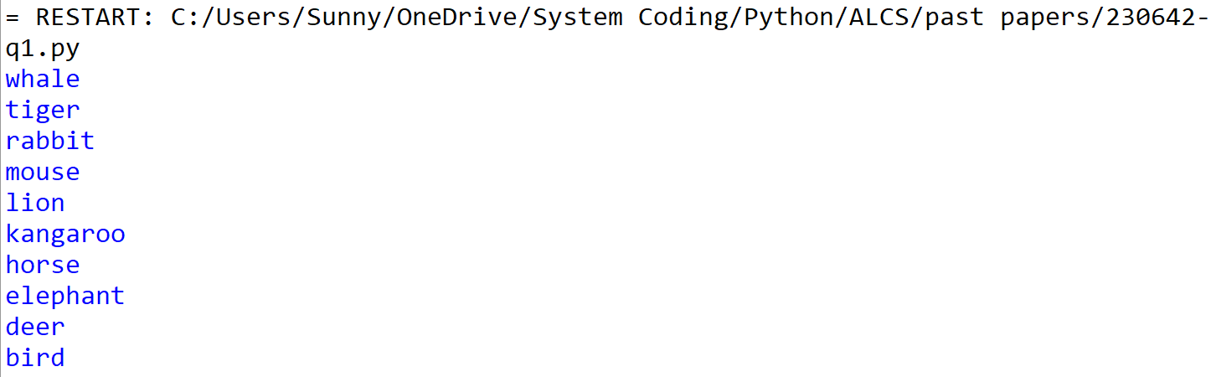

Question 2
Part 2(a)
class SaleData:
def __init__(self, ids, quantity):
self.id = ids
self.quantity = quantity

Part 2(b)
global CircularQueue
CircularQueue = [SaleData("", -1)] * 5
global Head, Tail, NumberOfItems
Head = 0
Tail = 0
NumberOfItems = 0

Part 2(c)
def Enqueue(x):
global CircularQueue, Tail, NumberOfItems
if NumberOfItems == 5:
return -1
else:
CircularQueue[Tail] = x
Tail += 1
if Tail >= 5:
Tail = 0
NumberOfItems += 1
return 1

Part 2(d)
def Dequeue():
global CircularQueue, Head, NumberOfItems
if NumberOfItems == 0:
return None
else:
tmp = CircularQueue[Head]
CircularQueue[Head] = SaleData("", -1)
Head += 1
NumberOfItems -= 1
return tmp

Part 2(e)
def EnterRecord(ids, q):
if Enqueue(SaleData(ids, q)) == 1:
print("Stored")
else:
print("Full")

Part 2(f)(i)
def main():
global CircularQueue
for i in range(6):
EnterRecord(input("Please enter ID: "), input("Please enter quantity: "))
t = Dequeue()
if t == None:
print("Empty!")
else:
print(f"ID: {t.id} Quantity: {t.quantity}")
EnterRecord(input("Please enter ID: "), input("Please enter quantity: "))
for i in range(len(CircularQueue)):
print(f"ID: {CircularQueue[i].id} Quantity: {CircularQueue[i].quantity}")

if __name__ == "__main__":
main()

Part 2(f)(ii)
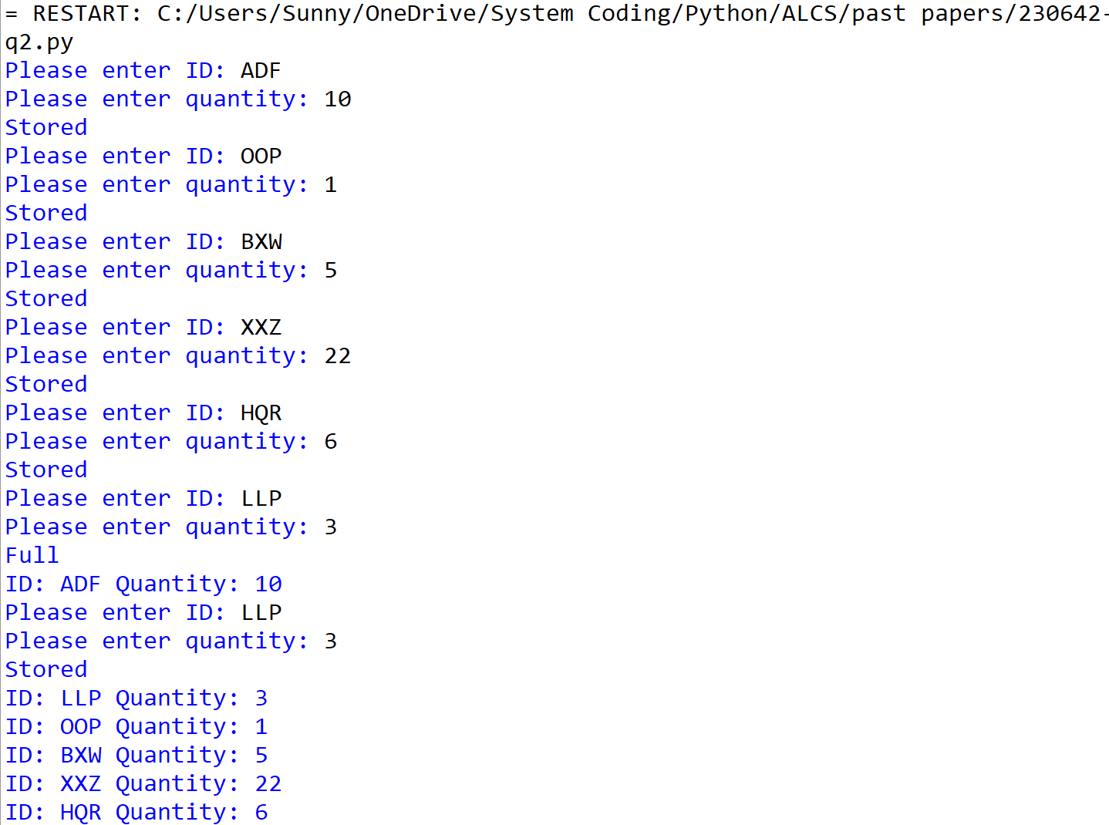

Question 3
Part 3(a)(i)
class Employee:
def __init__(self, h, e, j):
self.__HourlyPay = h #float
self.__EmployeeNumber = e #string
self.__JobTitle = j #string
self.__PayYear2022 = [0.0] * 51 #array of float

Part 3(a)(ii)
def GetEmployeeNumber(self):
return self.__EmployeeNumber

Part 3(a)(iii)
def SetPay(self, w, n):
pay = self.__HourlyPay * n
self.__PayYear2022[w] = pay

Part 3(a)(iv)
def getTotalPay(self):
total = 0
for i in range(len(self.__PayYear2022)):
total += self.__PayYear2022[i]
return total

Part 3(b)(i)
class Manager(Employee):
def __init__(self, h, e, j, b):
Employee.__init__(self, h, e, j)
self.__BonusValue = b #float

Part 3(b)(ii)
def SetPay(self, w, n):
n *= 1 + self.__BonusValue / 100
Employee.SetPay(self, w, n)

Part 3(c)
global EmployeeArray
EmployeeArray = [None] * 8
def main():
global EmployeeArray
idx = 0
with open('Employees.txt', 'r', encoding = 'utf-8') as f:
while True:
p = f.readline().strip()
n = f.readline().strip()
t = f.readline().strip()
if not p or not n or not t:
break
if not (t[0] > '9' or t[0] < '0'):
b = f.readline().strip()
EmployeeArray[idx] = Manager(float(p), n, b, float(t))
else:
EmployeeArray[idx] = Employee(float(p), n, t)
idx += 1

Part 3(d)
def EnterHours():
with open('HoursWeek1.txt', 'r', encoding = 'utf-8') as f:
while True:
n = f.readline().strip()
h = f.readline().strip()
if not h or not n:
break
for i in range(len(EmployeeArray)):
if EmployeeArray[i].GetEmployeeNumber() == n:
EmployeeArray[i].SetPay(1, float(h))

Part 3(e)(i)
def main():
global EmployeeArray
idx = 0
with open('Employees.txt', 'r', encoding = 'utf-8') as f:
while True:
p = f.readline().strip()
n = f.readline().strip()
t = f.readline().strip()
if not p or not n or not t:
break
if not (t[0] > '9' or t[0] < '0'):
b = f.readline().strip()
EmployeeArray[idx] = Manager(float(p), n, b, float(t))
else:
EmployeeArray[idx] = Employee(float(p), n, t)
idx += 1
EnterHours()
for i in range(len(EmployeeArray)):
print(EmployeeArray[i].GetEmployeeNumber())
print(EmployeeArray[i].getTotalPay())

if __name__ == "__main__":
main()

Part 3(e)(ii)
